Examples of Youth- Friendly Dental Practices
- Offer services that are accessible to youth

- Have a welcoming environment

- Use strengths-based approaches to care

- Encourage adolescents to return for follow-up care

- Collect feedback from adolescent patients

Take a moment to reflect upon a recent interaction with an adolescent patient.

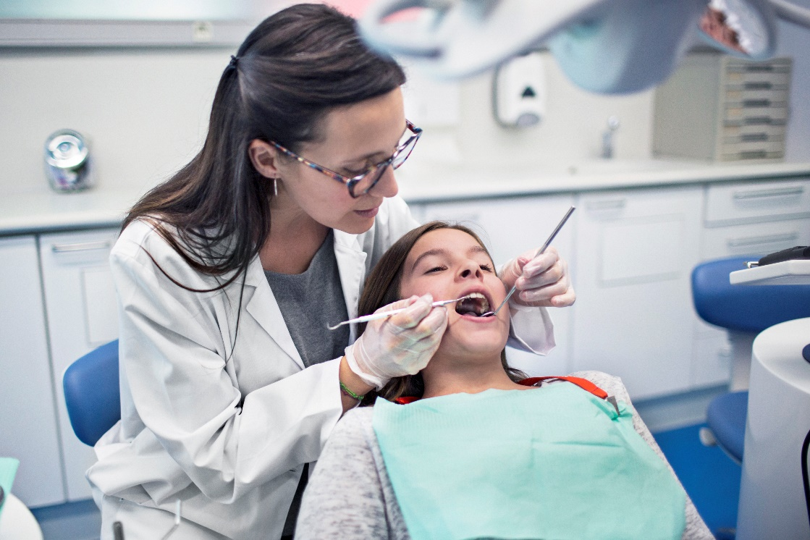

Reflection Questions:
- Did you utilize any strengths-based approaches?
- Were there any opportunities to make the interaction more strengths-based?

Examples of Youth- Friendly Dental Practices
- Offer services that are accessible to youth

- Have a welcoming environment

- Use strengths-based approaches to care

- Encourage adolescents to return for follow-up care

- Collect feedback from adolescent patients

Youth: “While I was waiting for my name to be called at the dentist office, my battery died on my cell phone! I literally cannot be without my phone, so I left. I’ll just make an appointment for some other time.”

Reflection Questions:
- What youth-friendly practices could the dentist office use to address this situation?
- What could your dental office do to avoid this situation?

Examples of Youth- Friendly Dental Practices
- Offer services that are accessible to youth

- Have a welcoming environment

- Use strengths-based approaches to care

- Encourage adolescents to return for follow-up care

- Collect feedback from adolescent patients

Youth: “It was starting to get hard for me to find a good time to schedule a dentist appointment between my basketball practice and after school tutoring. Luckily, the mobile dental unit is coming to our school next month, so I won’t have to miss school or practice!”

Reflection Question:
- What youth-friendly practice addresses this situation?
- What are some ways your dental office could extend its reach to accommodate adolescent patients?

